

**PAKISTAN STUDIES**

**ASSSIGNEMENT 01**

|  |  |
| --- | --- |
| **Name of Student** | **Mohammad Usama** |
| **Roll No** | **20K-0190** |
| **Section** | **BS(CS) Sec-B** |
| **Submitted To** | **Sir Jehangir** |
| **Submitted By** | **Mohammad Usama** |
| **Date of Submission** | **25 Feb, 2021** |

**Contents**

**War of Independence**

1. Introduction --------------------------------------------- 1
2. Causes Behind war of Independence ---------------- 1

2.1 Military ---------------------------------------------- 1

2.2 Religious -------------------------------------------- 1

2.3 Political ---------------------------------------------- 1

2.4 Accession of States --------------------------------- 2

2.5 Doctrine of Laps ------------------------------------ 2

2.6 Economic Cause ------------------------------------ 3

* 1. Cartridge of Grease ------------------------------- 3

1. Causes behind Failure ---------------------------------- 4

3.1 Lack of Leader Ship -------------------------------- 4

3.2 Lack of Transport ----------------------------------- 4

3.3 Betrayal of Sikhs ----------------------------------- 4

4. Impacts --------------------------------------------------- 4

4.1 Muslim as Disloyal -------------------------------- 4

4.2 Job and Libraries ----------------------------------- 4

**WAR OF INDEPENDENCE**

**Introduction:-**

The War of Independence is an important landmark in the history of Sub-Continent. This War was fought in 1857 by Indians against the British in order to get rid of their domination and The Mughal Emperor was in fear of loosing their domination which is ruling from hundreds of years. It is also given names as Indian Rebellion, Indian Mutiny as well as Indian Revolt. The main causes of the War were: political, social, economical, military and religious which are briefly discuss as follow.

***CAUSES BEHIND WAR OF INDEPENDENCE:***

**Military:-**

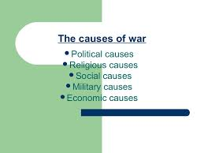 As British Army was comprises over (315000) soldiers in which (51000) were Britishers, and remaining were Muslims, Hindus, Christian, Sikhs and other Communities.

Figure 1

Here the issue raise is that British Government has the budget of 98 Lacs Pounds but the 50% was given to (51000) British Soldiers only and remaining 49 Lacs Pounds were distributive among (264000). One British Soldier Cavel Rijo who frequently rounds on Horse was given the amount of 27 Rupees and a People other than Britisher who were walk along the streets was given 2 Rupees and this leads towards War Of Independence.

**Religious:-**

French forces trying to impose Christianity in Sub-Continent. In 1837 there were an situation when people have nothing to eat so what British Government did, they said who ever converted to Christianity we will feed him/her and people were very rude with this behaviour “***We have to convert Hinduism into Christianity”*** Words by British Leaders.

**Political:-**

As Muslims ruled over Sub-Continent for a very long time, so it’s difficult for them to be someone’s command. To gain their power back they combined with Hindu and Sikhs as they were also disliking British rules and regulations. The great revolt of 1857 was the policy of Doctrine of Lapse. It was an annexation policy purportedly used by Lord Dalhousie as per which any princely state or territory under the British East India Company would automatically be annexed if the ruler died without a male heir.

**Accession of Sates:-**

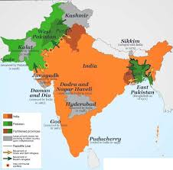There were some priory states in Sub-Continent. British were capturing them slowly slowly so the Inhabitant of Sub-Continent disliked this act of British Army.

Figure 2

* Satara
* Avadh
* Jhansi
* Jaitpur
* Carnatic
* Jaipur

**Doctrine of Laps:-**

Basically it was rule in Sub-Continent that who ever will die his successor will hold his power and property and if someone has no child so he/she can adopt a child to give his/her property, but this rule was eliminated by British Government and the new rule was that no one can adopt any child and if someone has no child so his/her property were snatch by British Government and this act was rudely for the people of Sub-Continent.

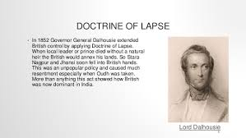

Figure

**Economic Cause:-**

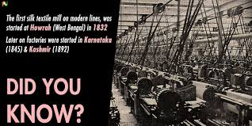Direct transformation of Money to London their Head Quarter was London and it was output of Indians, but it was being shared to London.

Figure 4

Secondly the Silk of Bengal was quality rated and expensive too, so they thought to control this Silk World (Which is ***Bangladesh*** now) for their right.

**Cartridge of Grease:-**

So the Cartridge of Grease was made up of (***Pig and Cows fat***) and the procedure for using this to take it in mouth and then put it into the gun for fire. Now the issue is that it’s Haram for Muslims to take that in Mouth because Pig is Haram for us and Cow’s fat is very near to Hindus and they are also avoiding this and this also creates sense of discrimination and then a soldier named Mangal fired a shot a The War Begins.

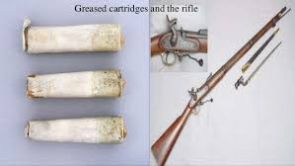



Figure 5

Figure 6 Soldier Named Mangal (From Movie)

***CAUSES OF FAILURE:***

**Lack of leadership:-**

So the Leadership of Indians were not good people are unite but they have no leaders for proper guide they are only killing people and have no particular plan on the other hand British Army was so clever they make a proper plan before doing anything and they have talented Officers and Generals who are fighting with minds not by hands.

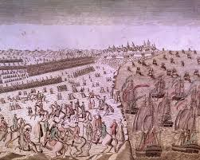 **Lack of Transport:-**

Figure 7

Well at that time British have every possible transport on the other hand people of Sub-Continent have nothing for transport. So if Indians want to send message or something else they have no Fast transport for this but British were quite Fast they will send their message by Telephones and weapons with Fast transport.

**Betrayal of Sikhs:-**

The Sikhs of Sub-Continent was not Loyal and were slod for some sort of money and comfort and help British by taking bribe form the people of Sub-Continent and for the world of British but in the end they were badly ignored.

In 1861 Indians were defeated and in the same year British Government hold the charge of and apply their laws.

***Impacts:***

**Muslim As Disloyal:-**

So after the War of Independence British started thinking that Muslims are not loyal, they can try to do wrong with us so we have to limitize them. At that time Sir Syed Ahmed Khan Wrote Loyal Muhammadan so British trust upon him.

**Jobs and Libraries:-**

Muslims will not be upgraded to higher level and not promoted but British were and this is not fair. Libraries and books were burned and the cause for this is, that the people of Sub-Continent will not educate themselves and remain uneducated.